Reducing E-Waste in K–12 Schools Through Sustainable Technology Management
Griffin Hulet
SUST-C490
4/1/2026

Summary
Technology is a major part of K–12 education, with schools relying on devices like iPads, laptops, and desktop computers for daily instruction. Many school districts manage thousands of devices at once, and these devices are constantly being used, damaged, and replaced. While technology improves learning, it also creates a growing issue with electronic waste, also known as e-waste. E-waste is one of the fastest growing waste streams in the world, and improper disposal can release harmful materials into the environment, including toxic metals and microplastics (Zhong et al., 2026).
A major issue in school technology management is the tendency to replace devices too quickly instead of repairing or reusing them. Devices are often replaced due to minor damage, performance issues, or age, even when they could still be functional. This leads to unnecessary costs for school districts and contributes to environmental harm. At the same time, many districts do not have structured systems in place for managing the full lifecycle of their technology.
This paper argues that K–12 schools need to adopt more sustainable technology management practices by focusing on extending the lifespan of devices. Key strategies include prioritizing repair over replacement, expanding refurbishment and reuse programs, improving recycling systems, and implementing reverse logistics processes. These approaches can reduce e-waste, lower costs, and improve efficiency. Overall, sustainable technology management is both a practical and necessary step for schools moving forward.

Introduction / Background
The use of technology in K–12 education has grown significantly over the past decade. Many schools have adopted 1:1 device programs, where each student is assigned a device for learning. This has increased access to digital tools and improved educational opportunities, but it has also created new challenges related to managing large numbers of electronic devices.
E-waste refers to discarded electronic devices and their components. As schools continue to rely heavily on technology, the amount of e-waste generated also increases. This is a major environmental concern because electronic devices contain hazardous materials that can contaminate soil and water if not disposed of properly. Research has shown that materials from e-waste can release harmful substances into aquatic environments, leading to long-term environmental damage (Zhong et al., 2026).
One of the main problems in school technology systems is the lack of long-term lifecycle management. Devices are often replaced instead of repaired, even when the issue is minor. This creates unnecessary waste and increases costs for school districts. In many cases, there are no clear policies or processes for deciding whether a device should be repaired, reused, or replaced.
Sustainability concepts such as lifecycle management and circular economy principles offer a better approach. Lifecycle management focuses on extending the usable life of devices, while circular economy principles emphasize reuse, repair, and recycling instead of disposal. Reverse logistics systems support these ideas by creating structured processes for collecting, evaluating, and managing used devices (Singh et al., 2025).
On a broader level, e-waste is connected to global sustainability and climate goals. Managing electronic waste effectively is important for reducing environmental impact and supporting long-term sustainability efforts (Malik et al., 2026). Policy approaches such as Extended Producer Responsibility also highlight the importance of shared accountability in managing electronic products throughout their lifecycle (ALqodsi, 2025).

1. Prioritizing Repair Over Replacement
One of the biggest issues in school technology management is how quickly devices are replaced. In many cases, devices are replaced even when the problem is minor, such as a damaged screen, battery issue, or software problem. This leads to unnecessary waste and higher costs.
A repair-first approach should be implemented in school IT departments. This means that before a device is replaced, it should be evaluated and repaired if possible. Schools can also standardize troubleshooting processes so that technicians follow consistent steps when diagnosing issues.
Research shows that improving repairability in electronics can significantly reduce e-waste and extend the lifespan of devices (Parvini & Hajalilou, 2026). By focusing on repair, schools can reduce costs while also minimizing environmental impact.

2. Expanding Refurbishment and Reuse Programs
Refurbishment and reuse are important strategies for extending the life of technology. Instead of discarding older devices, schools can repurpose them for different uses.
For example, older devices can be reassigned to lower grade levels, used for training purposes, or kept as backup devices. In addition, parts from damaged devices can be salvaged and reused to repair other devices.
Research supports this approach, showing that reclaiming and reusing electronic components can significantly reduce waste in educational environments (Nikoloudakis & Rangoussi, 2025). This allows schools to get the most value out of their existing resources and reduces the need to purchase new devices.

3. Improving Recycling and Resource Recovery
Even with repair and reuse strategies, devices will eventually reach the end of their lifecycle. When this happens, proper recycling becomes essential.
E-waste contains valuable materials such as gold, silver, and other metals that can be recovered and reused. Studies show that effective recycling systems can reduce environmental impact by recovering these materials and minimizing waste (Francini et al., 2025).
At the same time, improper disposal of e-waste can lead to serious environmental and social issues. For example, informal recycling practices in some parts of the world expose workers to harmful conditions and contribute to pollution (Nkansah-Dwamena, 2026).
Schools should partner with certified e-waste recyclers to ensure that devices are handled responsibly. This helps reduce environmental harm and supports sustainable resource management.

4. Implementing Reverse Logistics Systems
Reverse logistics refers to the process of managing products after they are no longer in use. This includes collecting, evaluating, repairing, refurbishing, and recycling devices.
In a school setting, reverse logistics can include structured device return programs, evaluation workflows, and clear decision-making processes. For example, when a device is returned, it can be assessed and categorized as repairable, reusable, or ready for recycling.
Research shows that reverse logistics systems improve efficiency and sustainability in managing electronic products (Singh et al., 2025). Implementing these systems helps schools better control how devices are handled throughout their lifecycle.

5. Developing Policy and Administrative Support
For sustainable technology management to be successful, schools need support at both the building and district level. While individual schools can adopt basic repair and reuse practices, long-term impact requires district-wide policies that standardize decision-making across all schools.
District leadership should establish clear guidelines that define when devices should be repaired, reassigned, or replaced. These policies should be supported by data tracking systems that monitor repair frequency, device lifespan, and cost trends. This allows administrators to make informed financial and operational decisions.
In addition, procurement policies should prioritize devices that are durable, repairable, and supported by long-term warranties. This aligns with broader sustainability frameworks such as Extended Producer Responsibility, which emphasizes shared accountability between organizations and manufacturers (ALqodsi, 2025).
Without administrative support, sustainable practices are difficult to maintain consistently. With it, schools can shift from reactive decision-making to a structured, long-term lifecycle strategy.

6. Implementation Framework: How Schools Can Apply These Practices
Successful implementation of sustainable technology management practices depends on how schools structure and support these changes. While the strategies discussed in this paper are effective, they must be adapted based on school size, available resources, and administrative organization. A combination of school-level actions and district-level coordination is necessary to achieve meaningful and long-term impact.
School-Level Implementation (Individual Buildings)
Individual schools can begin implementing sustainable practices without requiring major policy changes. Staff can follow standardized troubleshooting workflows before submitting device replacement requests, ensuring that repair is always considered first. Schools can also promote proper device handling among students to reduce preventable damage. In addition, existing staff can perform basic repairs and diagnostics, especially for common issues such as screen damage or battery replacement. Tracking frequent device problems can also help identify patterns and reduce repeat issues over time. These actions require minimal funding but can significantly decrease unnecessary device replacements.
District-Level Implementation (Primary Driver)
While individual schools can make improvements, the most impactful changes occur at the district level. District IT departments are responsible for purchasing, inventory management, and large-scale decision-making, making them the primary drivers of sustainable technology practices. District-wide initiatives should include establishing formal repair-first policies, creating structured refurbishment and device reassignment programs, and partnering with certified e-waste recyclers. In addition, districts should implement reverse logistics systems to manage device collection, evaluation, and redistribution. Centralizing repair operations can further improve efficiency and ensure consistency across all schools within the district.
Funding and Resource Considerations
Some sustainability initiatives require initial investment, but they often result in long-term financial savings. For example, schools may need to allocate resources for training repair technicians, purchasing replacement parts, or implementing systems to track device lifecycle data. Funding for these initiatives can come from existing technology budgets by reallocating funds that would otherwise be spent on device replacement. Additional support may be available through state or federal education funding programs, as well as grants focused on sustainability or infrastructure improvements. Over time, repair-first approaches can reduce overall spending by decreasing the number of new devices that must be purchased.
Phased Implementation Approach
To avoid overwhelming staff and resources, schools should adopt a phased approach to implementation. In the first phase, schools can standardize repair workflows and focus on reducing unnecessary device replacements. The second phase can introduce refurbishment and reuse programs to extend the life of existing devices. In the third phase, schools can develop partnerships with certified recyclers and establish reverse logistics processes. Finally, the fourth phase should focus on creating formal district policies and implementing long-term tracking systems to support continuous improvement. This step-by-step approach allows schools to gradually transition toward sustainable technology management while maintaining operational stability.

7. Economic and Environmental Impact
Extending the lifespan of devices provides both financial and environmental benefits. Schools can reduce costs by decreasing the number of devices that need to be replaced each year.
At the same time, reducing e-waste helps lower environmental impact and supports sustainability goals. Managing technology more efficiently also aligns with broader efforts to address climate challenges (Malik et al., 2026).

Conclusion
The increased use of technology in K–12 schools has led to a rise in electronic waste and higher costs for school districts. Many schools currently rely on replacing devices instead of managing their full lifecycle, which creates unnecessary waste and financial strain.
This paper shows that a more sustainable approach is possible. By prioritizing repair, expanding reuse and refurbishment, improving recycling systems, and implementing reverse logistics, schools can manage technology more effectively. Overall, sustainable technology management is both practical and necessary for long-term success.

Literature Cited
Parvini, E., & Hajalilou, A. (2026). Toward 4R electronics. Advanced Materials Technologies.
Francini, A., Cornelio, A., Bontempi, E., et al. (2025). Environmental assessment of noble metals recovery from e-waste. Journal of Cleaner Production.
Singh, A., Goel, A., Chauhan, A., et al. (2025). Reverse logistics and e-waste management. Sustainable Futures.
Malik, A. H., Rehan, M., Hussain, A., et al. (2026). E-waste and sustainability goals. Technology in Society.
ALqodsi, E. M. (2025). Extended producer responsibility. Sustainable Development.
Nikoloudakis, N., & Rangoussi, M. (2025). Reuse in education systems. International Journal of Sustainability in Higher Education.
Zhong, Z., Du, X., Wang, Z., et al. (2026). E-waste environmental impact. Water Research.
Nkansah-Dwamena, E. (2026). Global e-waste challenges. Journal of Environmental Management.
Xu, S. X., Xu, G., Li, G., et al. (2025). E-waste recycling systems. Naval Research Logistics.
Francini, A., Cornelio, A., Bontempi, E., et al. (2025). Resource recovery from e-waste. Journal of Cleaner Production.
Figures and Tables
Figure 1: Device Lifecycle Model
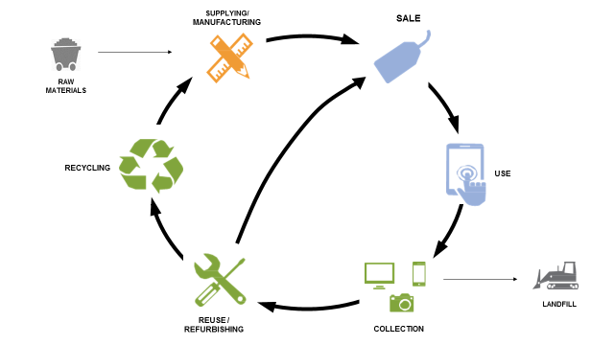
Figure 2: Repair vs Replacement Costs
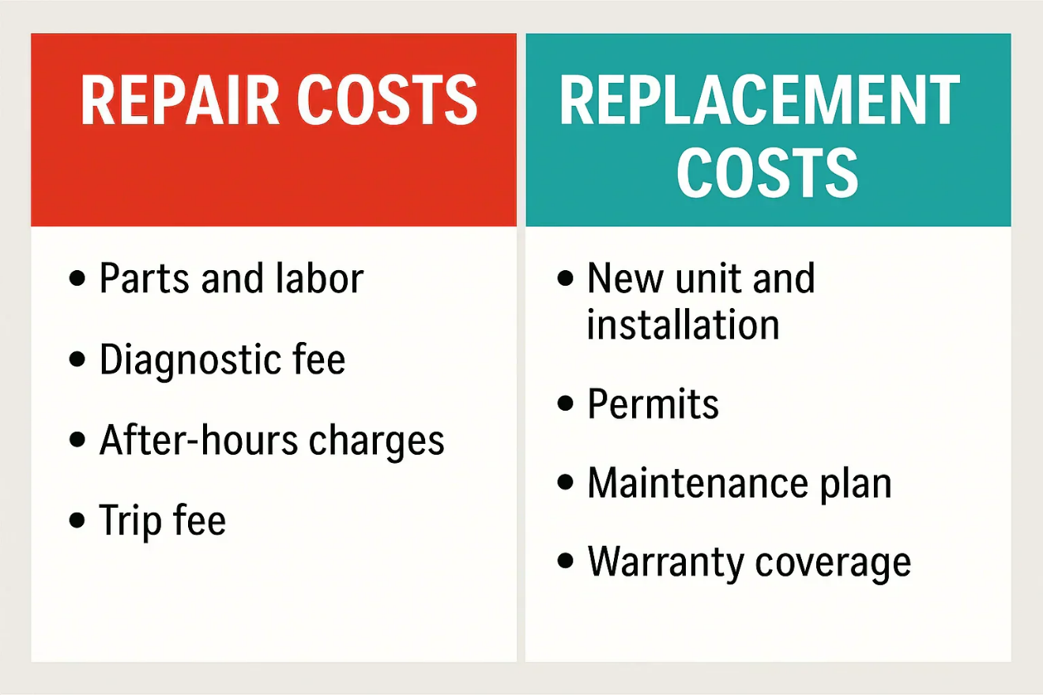
Table 1: Device Lifecycle Strategies and Benefits
Strategy | What it does | Benefit
Repair | Fix broken devices | Extends lifespan
Reuse | Reassign devices | Saves money
Refurbish | Restore devices | Maximizes value
Recycle | Recover materials | Reduces waste
Table 2: Repair vs Replacement Comparison
Factor | Repair | Replace
Cost | Low | High
Time | Medium | Fast
Environmental impact | Low | High
Sustainability | High | Low

